



# Service Charter

Putting people with disability at the centre of everything we do.

## Table of Contents

Service Charter 1

Table of Contents 2

Introduction 3

About us 4

Who we serve 4

Our Service Commitments 5

How you can help us 6

Working with an advocate 6

Privacy 6

We welcome feedback 6

You can: 7

Making a complaint about our service 9

We will work with you to resolve your complaint 9

Our approach is to: 10

The Values that guide our work 11

## Introduction

Australians want to optimise the independence and full participation of people with disability in our community. We are pioneering a new way to do this called the National Disability Insurance Scheme (NDIS).

The NDIS aims to give people with disability better access to personalised, high-quality, innovative supports and services. A specific focus is to enhance the independence, social and economic participation of people with disability and their carers.

## About us

The National Disability Insurance Agency (NDIA) assists people with disability, their families and carers to participate in the NDIS.

Our role is to connect people with information and resources and offer guidance as they plan for, select and use the supports, services and community activities they need.

**Most importantly, we put people with disability - current and future - at the centre of everything we do.**

We welcome, respect and include diverse cultures, perspectives and life experiences as we develop our service.

## Who we serve

Together with the Australian community – including Federal and State Governments and service providers - we are working to build a national scheme that is fair, effective and financially viable so that many more people can benefit from it in the years ahead.

The NDIS is currently being trialled in a number of locations around Australia. In each of these trial sites, we serve people with a disability who are eligible to participate in the NDIS, including those who may benefit from early intervention.

We also serve families, carers and representatives of people with disabilities and those who need information about the NDIS or other disability-related services available in these communities. This includes people who may not be eligible for the NDIS.

As we move from a series of trials to a national scheme, we expect the NDIA’s services will expand to reach more than 460,000 Australians with disability.

## Our Service Commitments

We work with people with disability - and those important to them - to develop and implement individual plans to help them achieve their goals.

We will:

* Provide choice and control in accessing the most appropriate supports and services
* Provide support to become more independent and included in the community
* Recognise and uphold informal support and care arrangements
* Welcome, respect and value feedback
* Raise awareness and knowledge in the community of how to support people with disability.

These commitments were developed in line with the UN Convention on the Rights of Persons with Disabilities and the National Disability Standards. They also reflect feedback from many people involved in the recent NDIS trials.

All employees of the NDIA are responsible for making sure that we deliver on these commitments. We describe our approach and the standards we are working towards in our Service Charter Action Plan.

We will share details of our progress and performance in our Annual Report.

## How you can help us

To help us provide the best possible service, we ask that you tell us:

* About you, including any special requirements or if anything changes like your contact details.
* About other people we can work with to better assist you.
* If you need clarification on any information we provide.
* In advance, if you cannot attend a meeting with us.
* Your ideas, suggestions and feedback so we can improve our service.

These simple steps will help to build long-term relationships of understanding and trust between us. We will listen and respond and ask for your support and respect for our team as we work with you.

### Working with an advocate

If you need more support in making decisions about the NDIS and working with the NDIA. In that case, detailed information on our website about Advocacy Services is available to you.

### Privacy

We respect and protect the privacy and dignity of people with disability. We collect, store and update personal information to assist in providing services to meet their unique needs. This is done with strict confidentiality, guided by our Privacy Policy.

### We welcome feedback

We want to provide an excellent service today and in the future. To ensure we do this, we have a strong focus on listening to people with disability – and those important to them – to learn from their experiences, whether they are good or bad. Together, we all play an important role in helping to develop the NDIS for all Australians. We respect and value feedback and encourage people to share their concerns, compliments and suggestions with us.

### You can:

#### Contact your local office by phone or in person

We will take your call or see you immediately whenever possible. If the person you want to talk to is unavailable immediately. In that case, you can leave a message, and we will ensure they, or an NDIA representative, call you back within two business days. If a face-to-face meeting is preferred, we will make time to meet.

**Send an email to** [**feedback@ndis.gov.au**](mailto:feedback@ndis.gov.au)

We will acknowledge your feedback via email within the next business day.

**Call the NDIA on 1800 800 110**

We will assist you straight away.

**Please ring this number for a crisis or emergency related to your NDIS experience. For other emergencies, please call 000.**

**Together, we all play an important role in helping to develop the NDIS for all Australians.**



**Help us build a better service and NDIS**

We also regularly undertake focus groups, telephone surveys and questionnaires and invite you to participate in them as an additional way of providing feedback to us.

## Making a complaint about our service

We aim to understand and resolve concerns before they become complaints quickly.

If you would like to make a formal complaint about the National Disability Insurance Scheme or the National Disability Insurance Agency, there are a number of ways to do this:

Talk to our staff at your local office. They will try to fix your complaint on the spot.

Call us on:

1800 800 110

Email your complaint to us at [feedback@ndis.gov.au](mailto:feedback@ndis.gov.au)

Send a letter to:

Customer Complaints:

NDIA GPO Box 700, Canberra ACT 2601 C

There is a form you can use, if you wish, to help describe your complaint. This form is available at our offices or on our website.

### We will work with you to resolve your complaint.

We will work with you – and those important to you – to resolve your complaint.

Different types of complaints can be managed in different ways, and the team member assisting you can provide information about the best way to resolve it.

## Our approach is to:

* Take immediate action if it appears that there is a high risk of harm, neglect or abuse.
* Acknowledge complaints within the next business day after we receive them.
* Contact you within two business days of acknowledgement.
* Resolve 90% of complaints within 21 business days of receipt. More complex complaints may take longer to address.
* Keep you informed about the progress of your complaint at every stage.
* Publish information on our complaints management performance.
* We will contact you to talk to you or your representative about your complaint and may seek more information to help us better understand it.

With your permission, we will contact relevant people within the NDIA, provide them with details of the complaint and ask for their feedback or comments. We will let you know what they say regarding your complaint and discuss how best to resolve it.

If you are not satisfied with the approach or outcome of your complaint, you can ask a supervisor or manager to review your complaint and how it was handled.

If you are unsatisfied with how your complaint was managed, you may seek assistance from the Commonwealth Ombudsman.

You can:

Call the office of the Ombudsman on:

1300 362 072

Visit the website:

[Commonwealth Ombudsman Website – Making Complaint Page](http://www.ombudsman.gov.au/making-a-complaint)

## The values that guide our work

The commitments we make in our Service Charter are based on five values that guide all the actions and decisions of the NDIA.

Assurance: We are committed to ensuring certainty of funding for high quality, equitable and effective supports that respect the diversity of all people with disability

Empowerment: We work locally and in partnership with participants, their families and carers to ensure they have choice, control and a voice in determining the supports, services and community activities they need in their lives

Responsibility: We share a mutual responsibility with participants, the community and providers in providing high-quality supports that maximise potential, independence, integration and inclusion in the community

Learning: We see each task and interaction as an opportunity to learn and improve performance. We ask for and act on feedback, and constantly evaluate our performance.

Integrity: We aim to be fair and transparent. We will do as we say and say as we do to build trust and respect among people with disability, their families and carers, employees, providers and the community.

**We welcome, respect and include diverse cultures, perspectives and life experiences as we develop our service.**

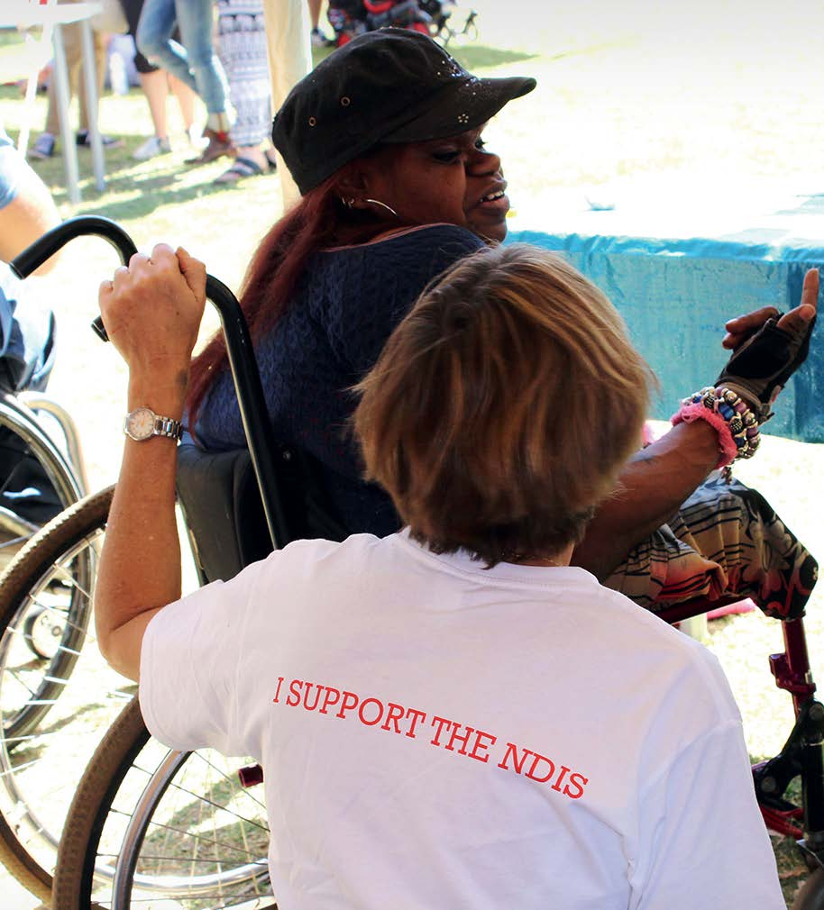

As employees of the Australian Public Service, our people are committed to providing impartial advice and service that is efficient and innovative; being open and accountable to the Australian community; being respectful to all people including their rights and their heritage; being ethical; demonstrating leadership that is trustworthy and acting with integrity.

**More information and detailed contact listing**

You can find out more information on the NDIS and the NDIA by visiting our website. More detail is also available on translations and accessibility via the “Contact us” section of our website.

**Tracking our performances and progress**

Senior leaders within the NDIA review progress against our Service Charter commitments quarterly. Results and opportunities for improvement will be published in our Annual Report.

Updates to the Charter will be considered annually taking into account feedback from people with disability, their families, carers and representatives.

**Putting people with disability at the centre of everything we do**

**Service Charter**

Call NDIA on **1800 800 110**

[**National Disability Insurance Scheme Website**](http://www.ndis.gov.au/)